**Smart Library Management System - Rationale**

**Introduction**

The Smart Library Management System is a lightweight Python project designed to automate and simplify basic library operations such as adding books, managing members, borrowing and returning books, and tracking availability. It provides a foundation for understanding modular programming, data structures (like dictionaries and lists), and CRUD operations in Python.

1. Purpose of the System Libraries often manage hundreds of books and users. Manually tracking these details can be time-consuming and prone to errors. The goal of this project is to: - Help students learn how data can be structured programmatically. - Demonstrate a mini digital library system using Python’s core features. - Provide a blueprint for future expansion (e.g., integrating with SQL or a web interface).

2. System Design The system follows a modular architecture, separating the logic and demonstration into two main files: - operations.py → Contains all core functions for managing books and members. - demo.py → Demonstrates how the system works with real examples. This modularity ensures that the logic (operations.py) can be reused or tested independently from the user interface (demo.py).

3. Data Structures The project uses Python dictionaries and lists as in-memory databases.

books (dict): Stores books by ISBN with details like title, author, and copies.

members (list): Stores member records including borrowed books.

genres (tuple): Stores fixed book genres to ensure consistency.

4. System Features - Add, search, borrow, return, and delete books.

Add, update, and remove library members. Check availability before borrowing. Prevent deleting borrowed books or active members. Easy to extend — can later include databases or GUI.

5. Design Rationale Each function was designed for clarity, reusability, and simplicity:

add_book() → ensures no duplicate ISBN and validates genre. search_book() → performs keyword-based lookups in title or author fields. add_member() / delete_member() → ensures unique IDs and clean deletions. borrow_book() / return_book() → updates availability dynamically. delete_book() → prevents deletion if copies are still borrowed.

6. UML Diagram A simplified class diagram represents how the main entities (Book and Member) interact within the system.

7. Future Enhancements The current system can be extended in several ways: Integrate with SQLite or PostgreSQL for data persistence. - Build a GUI using Tkinter or PyQt. - Create a web version using Flask or Django. - Add book return deadlines and fine tracking features.

**Conclusion**

The Smart Library Management System demonstrates how simple programming logic can manage real-world problems. It’s not only a coding exercise but also an introduction to the principles of system design, modularity, and data handling — key concepts in software engineering.

THE OPERATIONS.PY, DEMO.PY AND TEST.PY CODE IN PYCHARM

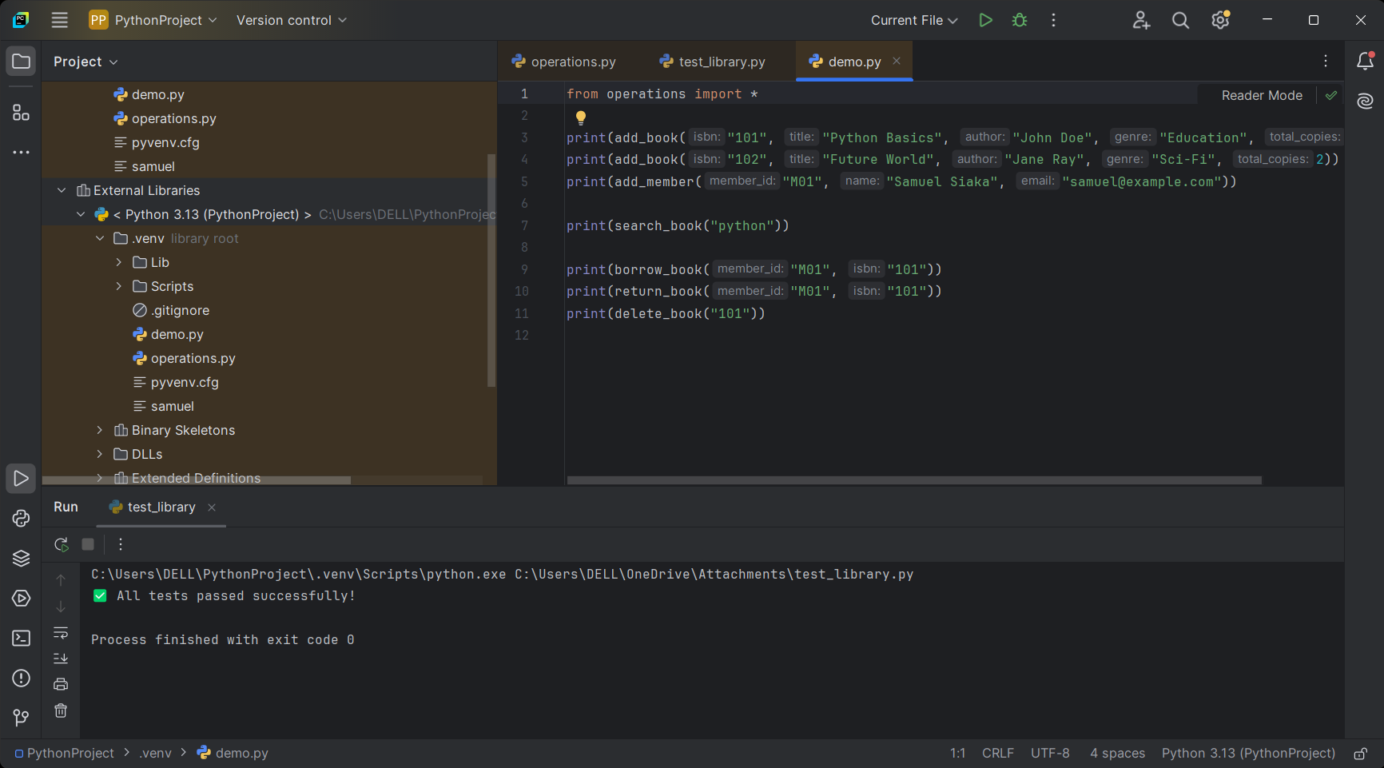

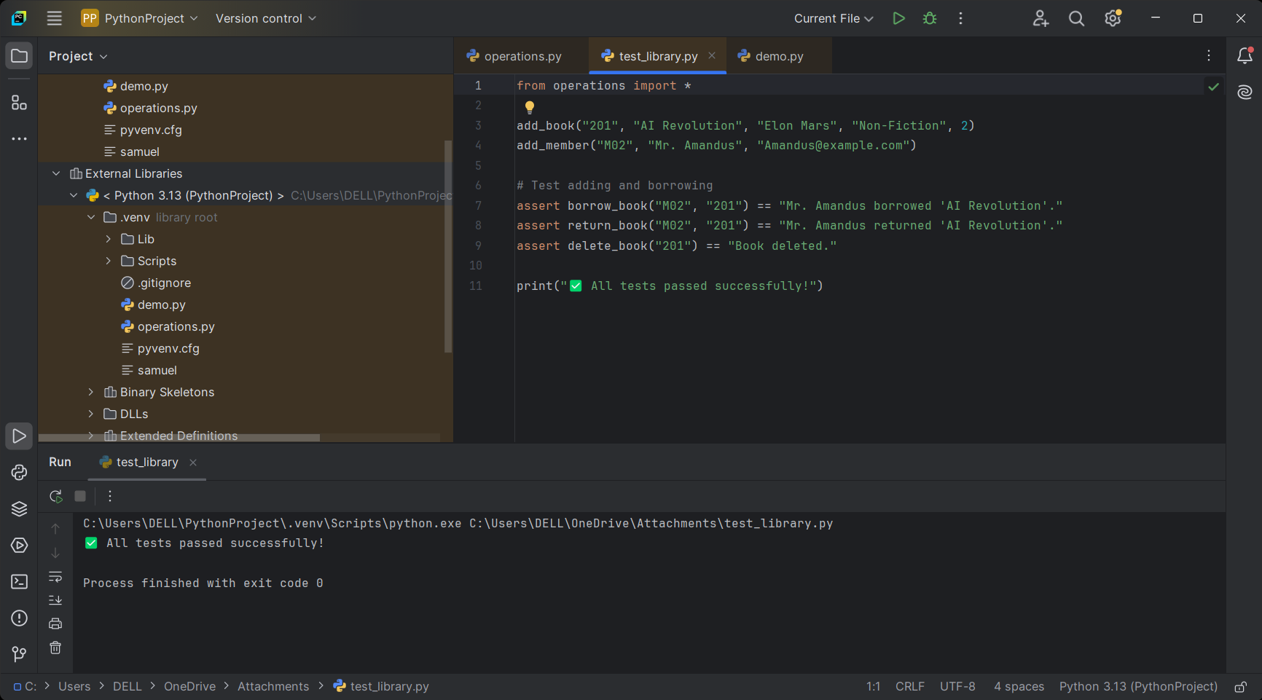

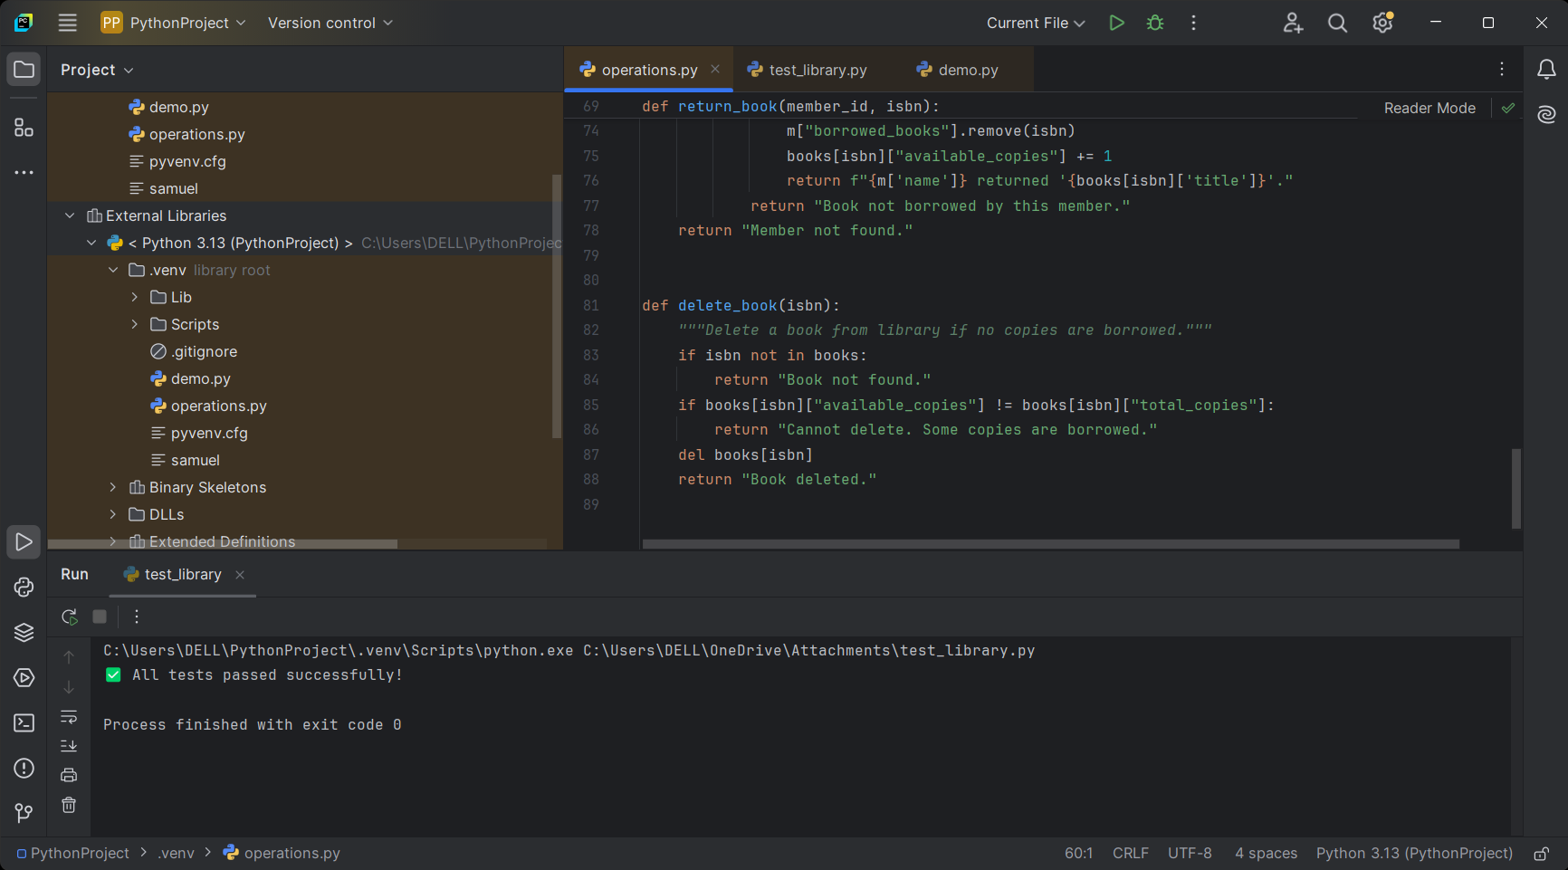

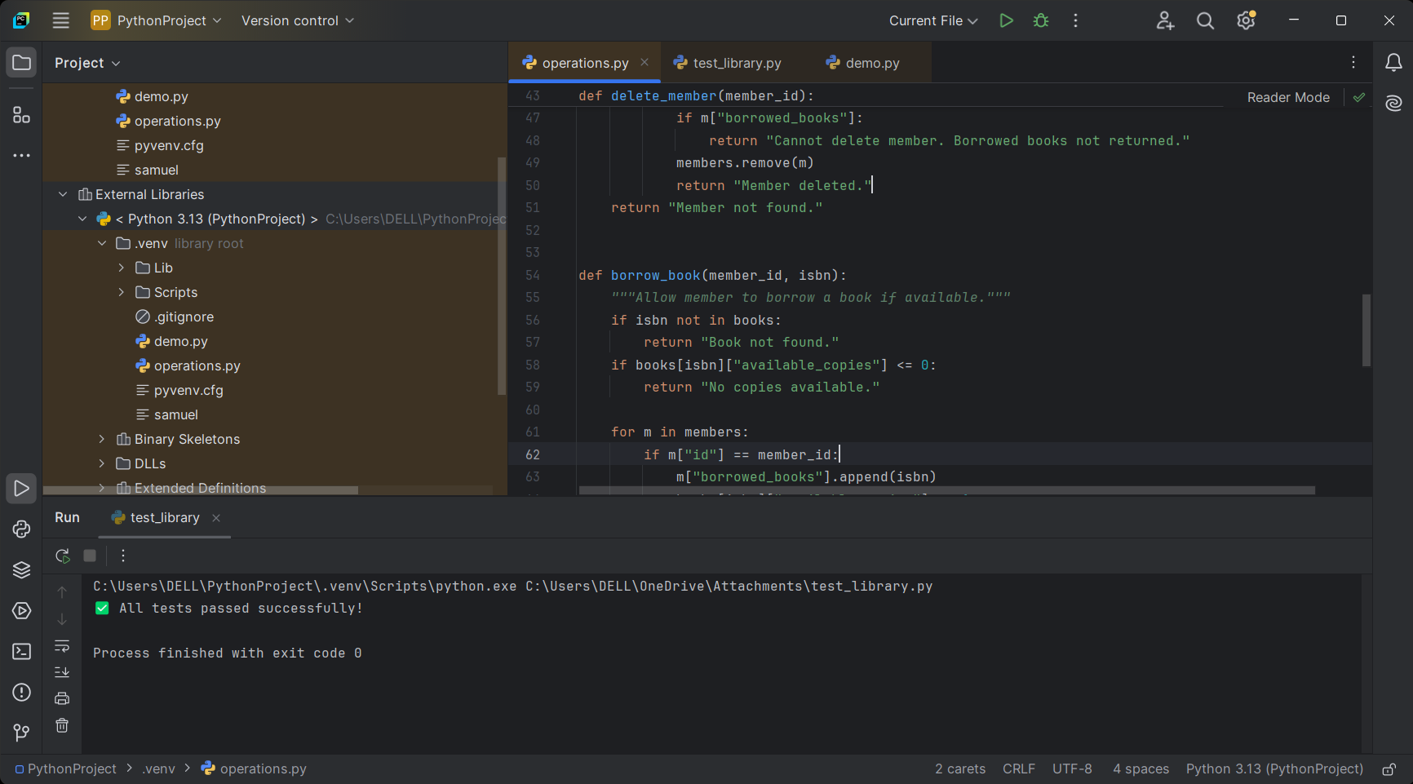

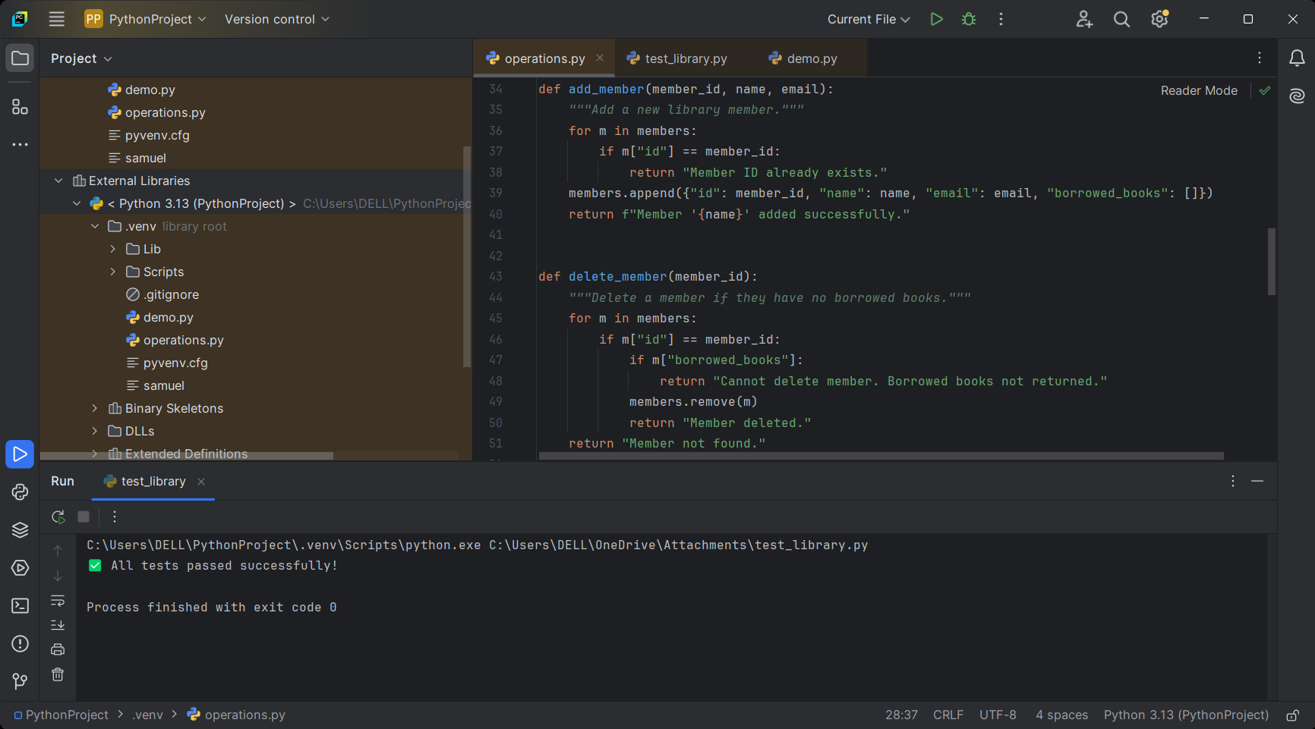

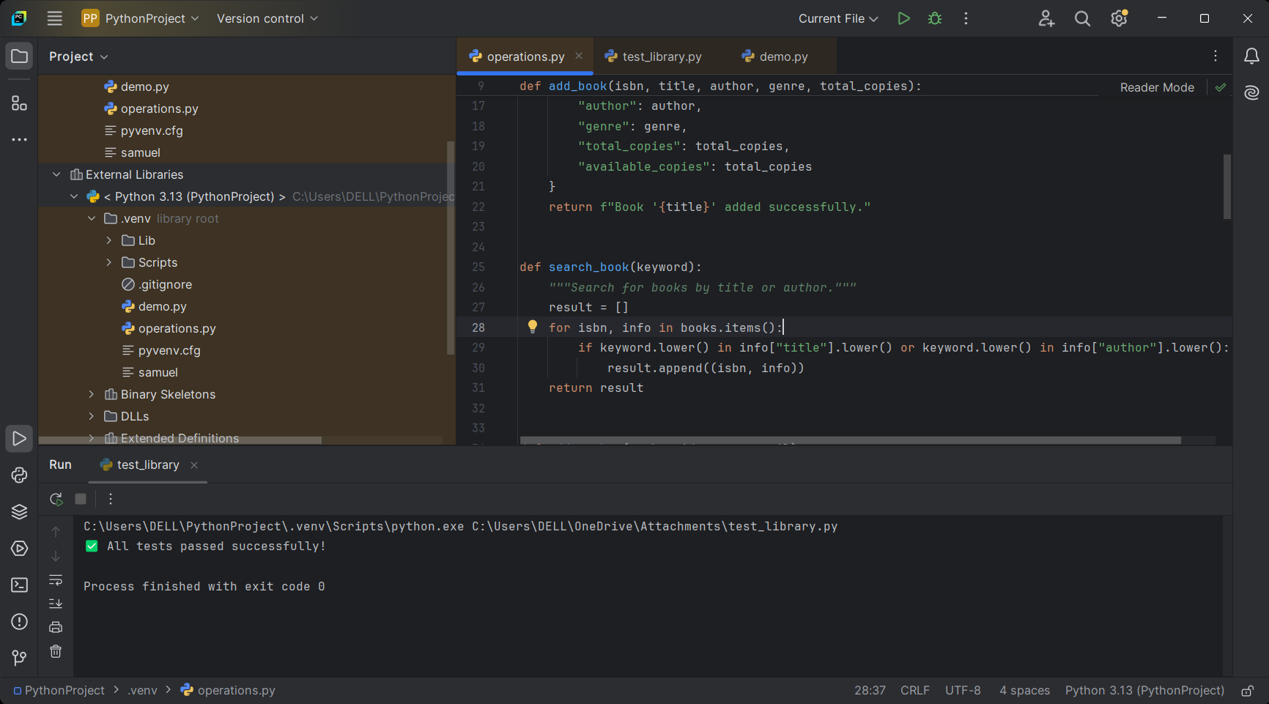

**UML DIAGRAM**

